**Abstract**

E-commerce is the activity of buying or selling of products on online services or over the Internet. Ecommerce is often used to refer to the sale of physical products online, but it can also describe any kind of commercial transaction that is facilitated through the internet. Electronic commerce draws on technologies such as mobile commerce, electronic funds transfer, supply chain management, Internet marketing, online transaction processing, electronic data interchange (EDI), inventory management systems, and automated data collection systems.

Whereas e-business refers to all aspects of operating an online business, ecommerce refers specifically to the transaction of goods and services.

**Types of Ecommerce Models**

There are four main types of ecommerce models that can describe almost every transaction that takes place between consumers and businesses.

1. Business to Consumer (B2C):   
When a business sells a good or service to an individual consumer (e.g. You buy a pair of shoes from an online retailer).

2. Business to Business (B2B):   
When a business sells a good or service to another business (e.g. A business sells software-as-a-service for other businesses to use)    
  
3. Consumer to Consumer (C2C):   
When a consumer sells a good or service to another consumer (e.g. You sell your old furniture on eBay to another consumer).  
  
4. Consumer to Business (C2B):   
When a consumer sells their own products or services to a business or organization (e.g. An influencer offers exposure to their online audience in exchange for a fee, or a photographer licenses their photo for a business to use).

**Application of E-Commerce**

* Social Networking
* Digital Wallet
* Electronic Tickets
* Online banking
* Teleconferencing
* Online Shopping and Order tracking
* Online office suits

**Impact on Market and Retailers**

E-commerce markets are growing at noticeable rates. The online market is expected to grow by 56% in 2015–2020. In 2017, retail e-commerce sales worldwide amounted to 2.3 trillion US dollars and e-retail revenues are projected to grow to 4.88 trillion US dollars in 2021. Traditional markets are only expected 2% growth during the same time.

E-commerce allows customers to overcome geographical barriers and allows them to purchase products anytime and from anywhere. Online and traditional markets have different strategies for conducting business. Traditional retailers offer fewer assortment of products because of shelf space where, online retailers often hold no inventory but send customer orders directly to the manufacture. The pricing strategies are also different for traditional and online retailers. Traditional retailers base their prices on store traffic and the cost to keep inventory. Online retailers’ base prices on the speed of delivery.

**Impact on supply chain management**

For a long time, companies had been troubled by the gap between the benefits which supply chain technology has and the solutions to deliver those benefits. However, the emergence of e-commerce has provided a more practical and effective way of delivering the benefits of the new supply chain technologies.

E-commerce has the capability to integrate all inter-company and intra-company functions, meaning that the three flows (physical flow, financial flow and information flow) of the supply chain could be also affected by e-commerce. The affections on physical flows improved the way of product and inventory movement level for companies. For the information flows, e-commerce optimized the capacity of information processing than companies used to have, and for the financial flows, e-commerce allows companies to have more efficient payment and settlement solutions.

**Impact on employment**

E-commerce helps create new job opportunities due to information related services, software app and digital products. It also causes job losses. The areas with the greatest predicted job-loss are retail, postal, and travel agencies. The development of e-commerce will create jobs that require highly skilled workers to manage large amounts of information, customer demands, and production processes. In contrast, people with poor technical skills cannot enjoy the wages welfare. On the other hand, because e-commerce requires sufficient stocks that could be delivered to customers in time, the warehouse becomes an important element. Warehouse needs more staff to manage, supervise and organize, thus the condition of warehouse environment will be concerned by employees.

**Impact on Customers**

E-commerce brings convenience for customers as they do not have to leave home and only need to browse website online, especially for buying the products which are not sold in nearby shops. It could help customers buy wider range of products and save customers’ time. Consumers also gain power through online shopping. They are able to research products and compare prices among retailers. Also, online shopping often provides sales promotion or discounts code, thus it is more price effective for customers. Moreover, e-commerce provides products’ detailed information; even the in-store staff cannot offer such detailed explanation. Customers can also review and track the order history online.

E-commerce technologies cut transaction costs by allowing both manufactures and consumers to skip through the intermediaries. This is achieved through by extending the search area best price deals and by group purchase. The success of e-commerce in urban and regional levels depend on how the local firms and consumers have adopted to e-commerce.

**Modern E-Commerce**

Modern electronic commerce typically uses the World Wide Web for at least one part of the transaction's life cycle although it may also use other technologies such as e-mail. Typical e-commerce transactions include the purchase of online books (such as Amazon) and music purchases (music download in the form of digital distribution such as iTunes Store), and to a less extent, customized/personalized online liquor store inventory services. There are three areas of e-commerce: online retailing, electric markets, and online auctions. E-commerce is supported by electronic business.

**Current E-Commerce Sites**

* **Flipkart**: is an Indian electronic commerce company based in Bengaluru, India. The company initially focused on book sales, before expanding into other product categories such as consumer electronics, fashion, and lifestyle products.
* **Amazon**: is a multinational technology company focusing in e-commerce, cloud computing, and artificial intelligence in Seattle, Washington. It is one of the Big Four or "Four Horsemen" of technology along with Google, Apple and Facebook due to its market capitalization, disruptive innovation, brand equity and hyper-competitive application process.
* **SnapDeal:** is an Indian e-commerce company based in New Delhi, India. The company was started by Kunal Bahl and Rohit Bansal in February 2010. Snapdeal was started on 4 February 2010 as a daily deals platform, but expanded in September 2011 to become an online marketplace.
* **Myntra:** **Myntra** is an Indian fashion e-commerce company headquartered in Bengaluru, Karnataka, India. The company was founded in 2007 to sell personalized gift items. Established by Mukesh Bansal along with Ashutosh Lawania and Vineet Saxena; Myntra sold on-demand personalized gift items. It mainly operated on the B2B (business-to-business) model during its initial years. Between 2007 and 2010, the site allowed customers to personalize products such as T-shirts, mugs, mouse pads, and others.
* **Swiggy:** Swiggy’s business model was born out of the need to create a seamless ordering and delivery experience for the customer, who wants a home delivery. One can order from any nearby restaurants through the click of a few buttons.

**About Our Project**

This project covers only the products Made in India and the products made by companies under Make In India initiative.

This not only would boost the Indian economy but also give Indian sellers a relief from foreign competitions.

The website would be used to sell many different kinds of goods like electronics, furniture, clothing, beauty products, etc.

India is known for the quality of the products such and handicrafts, handlooms, ayurvedic cosmetics, etc. And selling these would be the main objective of this website.

Due to this Employment for people in India increases as well as the competition by foreign companies would be subsided to a great extent as only companies making products within India would be able to register as sellers and henceforth the prices would be in contrast to the prices by Indian sellers.

Once employment and products are manufactured in India it can be Exported to other country.

This will increase the GDP (Gross Domestic Product) of the country.

Many new Entrepreneurs will come up with new ideas and further the development of the country will increase

**Technology Bucket**

**HTML5:** is a software solution stack that defines the properties and behaviors of web page content by implementing a markup based pattern to it.

HTML 5 is the fifth and current major version of the HTML standard, and subsumes XHTML.

**CSS:** Cascading Style Sheets (CSS) is a style sheet language used for describing the presentation of a document written in a markup language like HTML.

**BOOTSTRAP:** Bootstrap is a free and open-source front-end framework for developing websites and web applications. It contains HTML and CSS-based design templates for typography, forms, buttons, navigation and other interface components, as well as optional JavaScript extensions. Unlike many earlier web frameworks, it concerns itself with front-end development only.

**Code Table**

|  |  |  |  |
| --- | --- | --- | --- |
| **Page** | **Code** | **Style Sheet** | **Images** |
| **About** | **AB** | **Style1** | **Aboutus/images** |
| **ContactUS** | **CU** | **All.min,style** | **url** |
| **Index** | **IX** |  |  |
| **LogIn** | **LI** | **login** | **url** |
| **Product** | **PR** | **product** | **url** |
| **SignUp** | **SU** | **signup** | **url** |
| **Documentation** | **DC** |  |  |
| **Seller Form** | **SF** |  |  |
| **Add Address** | **AA** | **AddAddress** | **url** |
| **Saved Cards** | **SC** | **SavedCards** | **url** |
| **Shopping Cart** | **SS** | **ShoppingCart** | **Shopping/images** |
| **Grid** | **G** | **Grid** | **url** |
| **AddProduct** | **AP** | **AddProduct** | **url** |

**Documentation**

|  |  |  |
| --- | --- | --- |
| **LOG CODE**  (Code-Date-Time) | **Author** | **Description** |
| **DC-210119-0912** | **Akash** | **Drafted initial report** |
| **CU-220119-0720** | **Akhila.V** | **Created About Us Page** |
| **CU-220119-1920** | **Amrutha** | **Created Contact Page** |
| **DC-250119-1020** | **Arpit** | **Documentation Modified** |
| **SF-250119-1820** | **Arpit** | **Seller Registration form created** |
| **CU-220119-0720** | **Amrutha** | **Created Contact Page** |
| **CU-250119-1420** | **Amrutha** | **Styling And Background Added.** |
| **CU-250119-1430** | **Akhila.V** | **Changed the Background & added Parallax effect** |
| **DC-250119-2130** | **Amrutha** | **Added data to Report** |
| **SF-250119-2015** | **Arpit** | **Modified the sellerForm.html file** |
| **SF-250119-2127** | **Arpit** | **Addition of Style Sheet and Images for Seller Form** |
| **D-250119-2130** | **Arpit** | **Added data to Report** |
| **SU-250119-1830** | **Ashitha** | **Added icons** |
| **LI-250119-1845** | **Ashitha** | **Added icons** |
| **SS-260119-1150** | **Amrutha** | **Designed Shopping Cart pg** |
| **AA-260119-1020** | **Ashitha** | **Designed Add address pg** |
| **SC-270119-1120** | **Ashitha** | **Designed Saved Carts pg** |
| **SC-270119-0610** | **Ashitha** | **Updated document** |
| **SSU-300110-05** | **Ashitha** | **Designed seller signup pg** |
| **SS-300119-08** | **Amrutha** | **Added Images** |
| **IX-290119-1120** | **Akash** | **Changed the theme** |
| **IX-010219-1030** | **Akash** | **Changed the header and footer** |
| **BE-010219-10** | **Amrutha** | **Designed seller signup backend** |
| **BE-030219-04** | **Amrutha** | **Created database connection** |
| **AB-030219-0330** | **Arpit** | **Redesign of About US page** |
| **AP-060219-07** | **Ashitha** | **Made changes to Add product page** |
| **DC-070219-06** | **Ashitha** | **Updated documentation** |
| **BE-050219-0730** | **Akhila** | **Designed user signup backend** |
| **AB-120219-0800** | **Ashitha** | **Changed the background image and color of other pages** |

**Detailed Description**

* **DC-210119-0912:**
* **CU-220119-0720**: A form for About Us page No styling has been added as of now. Technology Bucket used is HTML, bootstrap, CSS.
* **CU-220119-1920:** a form for Contact page No styling has been added as of now. Technology Bucket used is HTML5,bootstrap,font awesome icons
* **DC-250119-1020:** Added information to project documentation regarding the rules to be followed to fill the documentation. Also added information about code **CU-220119-0720** and **CU-220119-1920.**
* **SF-250118-1820:** a form for registration of sellers is created as sellerForm.html. No styling has been added as of now. Technology Bucket used is HTML5.
* **CU-220119-0720:** a form for Contact page No styling has been added as of now. Technology Bucket used is HTML5,bootstrap,font awesome icons
* **CU-250119-1420:** styling and background added Technology Bucket used is CSS and online image.
* **CU-250119-1430:** changed the background and added parallax effect Technology Bucket used is CSS Font awesome.
* **DC-250119-2130:** added information about the changes made to Contact Us page to the project documentation. Including details about changes in code **CU-250119-1430**.
* **SF-250119-2015:** Modifications done to the sellerForm.html file added fields like password and link to terms and condition document. No styling added as of now and also the link to Terms and Condition Document is currently a blank link.
* **SF-250119-2127:** Added a CSS file for seller form and brought into place styling effects to the html file. Also added a folder containing images related to the seller form.
* **DC-250119-2130:** Updated the project documentation to the latest available information.
* **SU-250119-1830:** Added icons to signup page and login page**.**
* **AB-030219-0330**: Redesign of About Us page. New File names are aboutUs.html and .aboutus/style.css
* **AP-060219-0700:** Made changes to Add product page
* **AB-120219-0800:** Made changes to login ,aboutus and signup page

**PAGE LAYOUTS**

1. **Home Page**

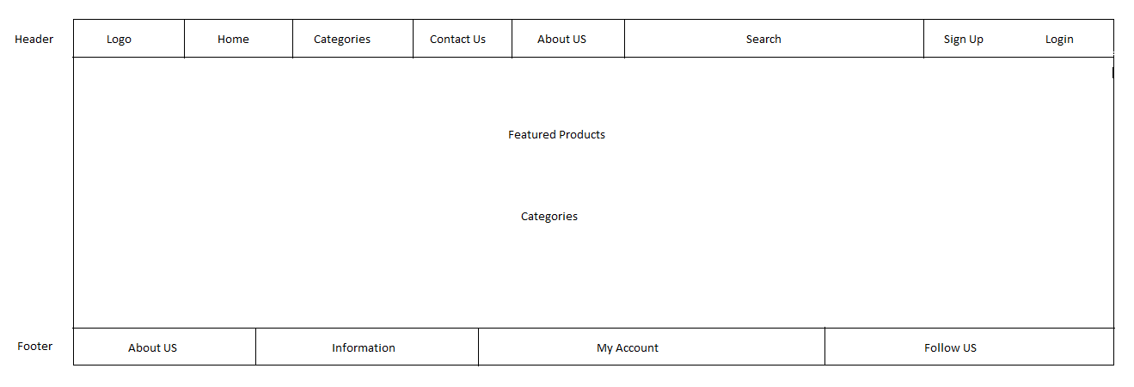

1. **About Us**

Header

**About US**

Information

**OUR TEAM**

Footer

1. **Contact Us**

Header

Map

First name: Last name: Username:

City: State: Zip:

SUBMIT form

Footer

1. **Categories**

Categories

Handloomas

Handicrafts

Furnitures

Electronics

Ayurveda

Antique

Footer

1. **Sub Categories**

Header

P2

P4

P3

P1

P6

P8

P7

P5

Footer

1. **Product Page**

Header

PRODUCT DETAILS

IMAGE

Name

Description

Price:

Quantity:

Add to cart

Buy Now

Description Specification

Footer

1. **Cart**

Header

Enter the promotional code

5 items in your bag

Sub total

Total

Apply

Image Price Quantity Subtotal

Select collection/delivery

GO TO CHECKOUT

Footer

1. **Shipping Details**

Header

Shipping Details

Shipping Address:

New Address:

Add Address

Proceed

Footer

1. **Login**

Header

LOGIN

Email Address:

Password:

Remember me

SUBMIT

Footer

**SNAPSHOTS:**

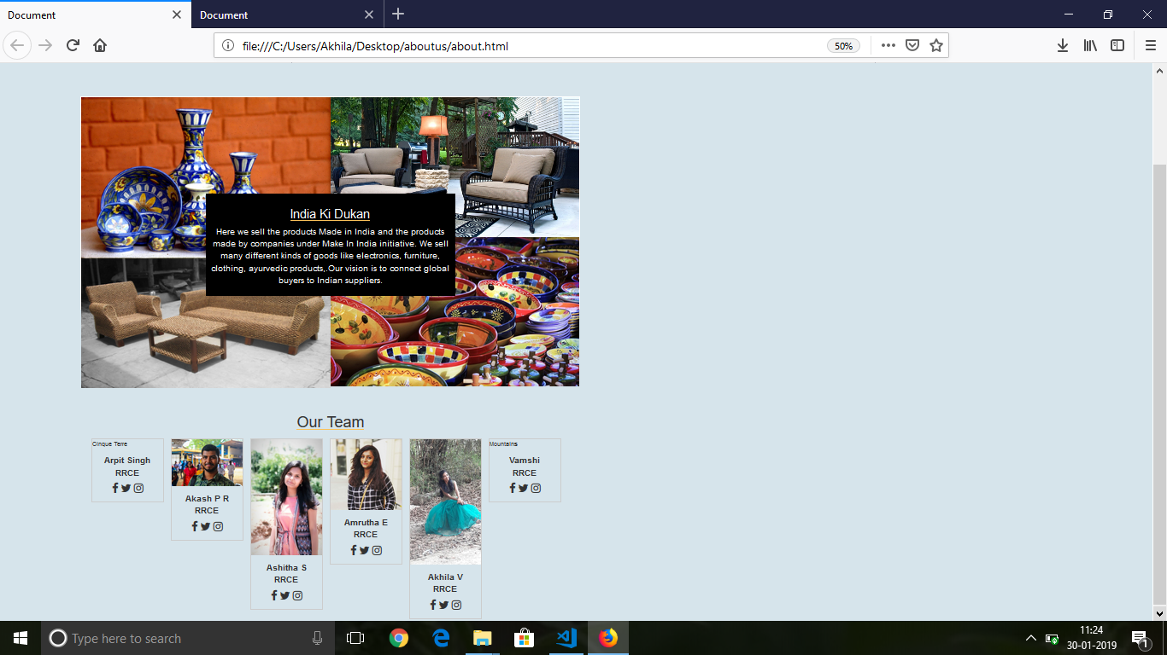

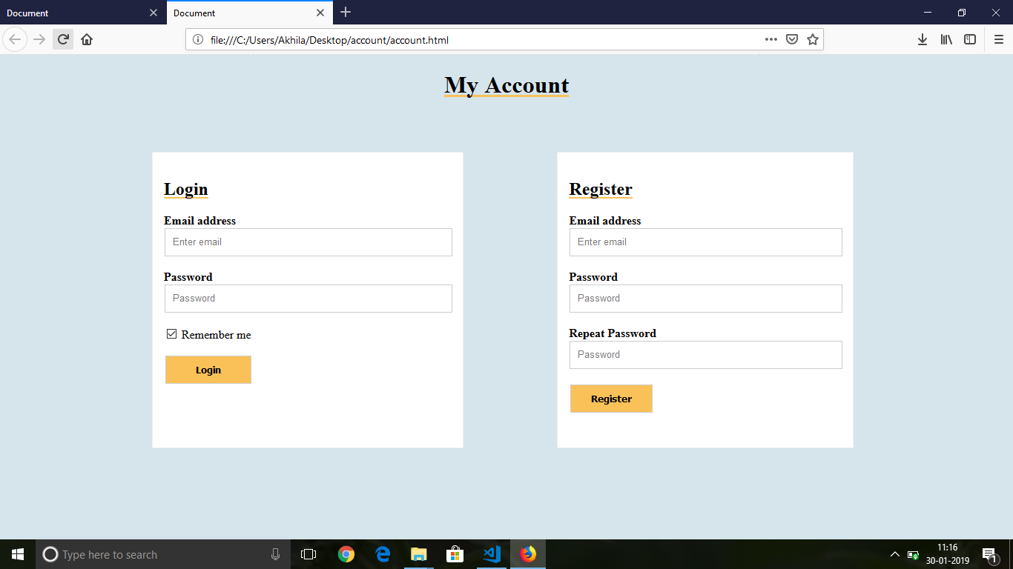

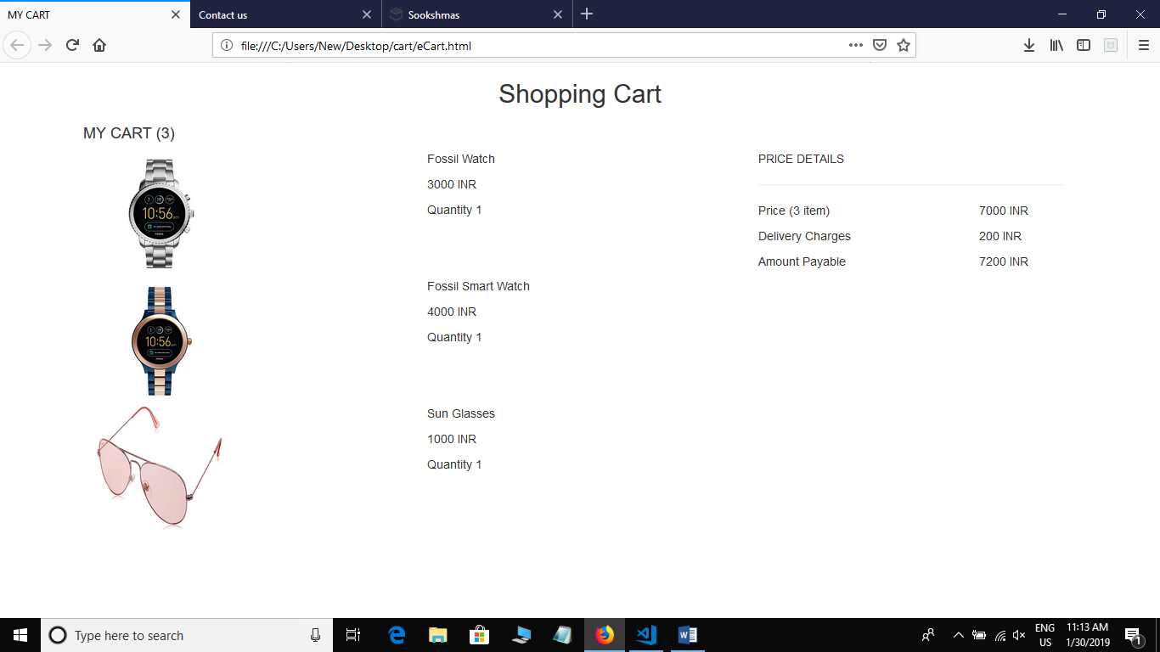

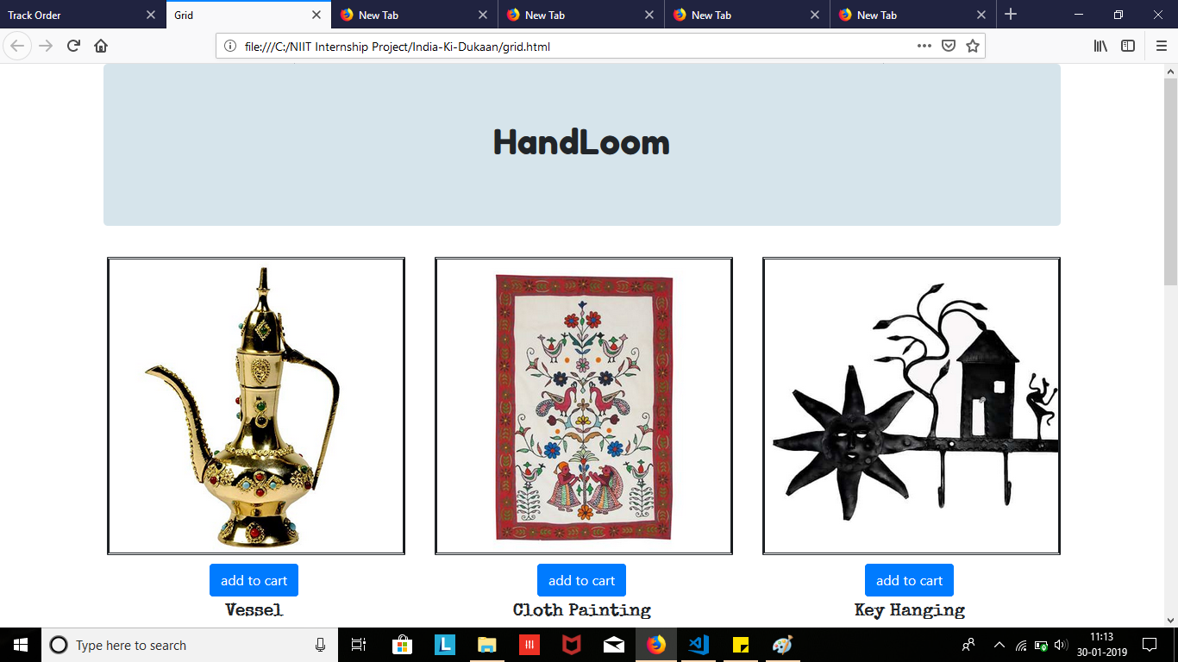

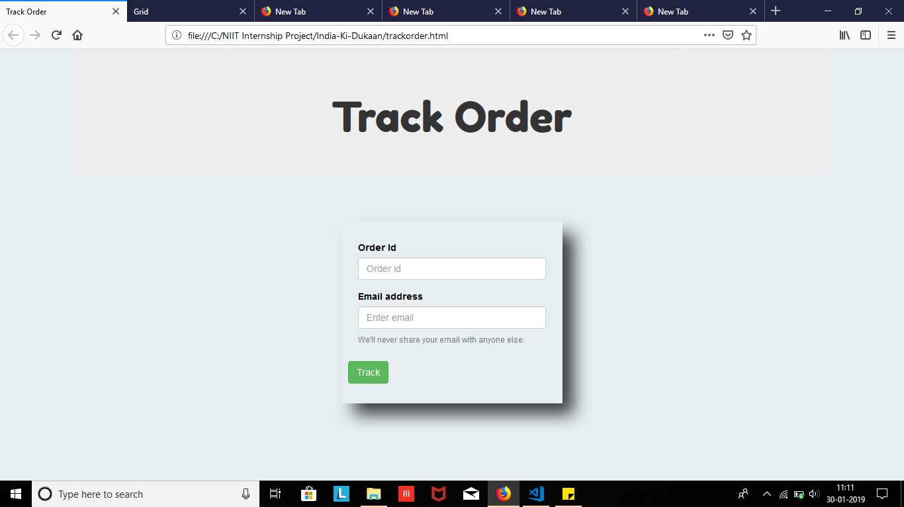

**Team Members**

Arpit Singh [Team Leader]

Akash P Rajasekharan

Ashitha S

Akhila V

Amrutha E

Vamsi Kumar